**DOCUMENTATION**

This documentation contains the brief description of the functionality of each page.

1. **Home Page:**

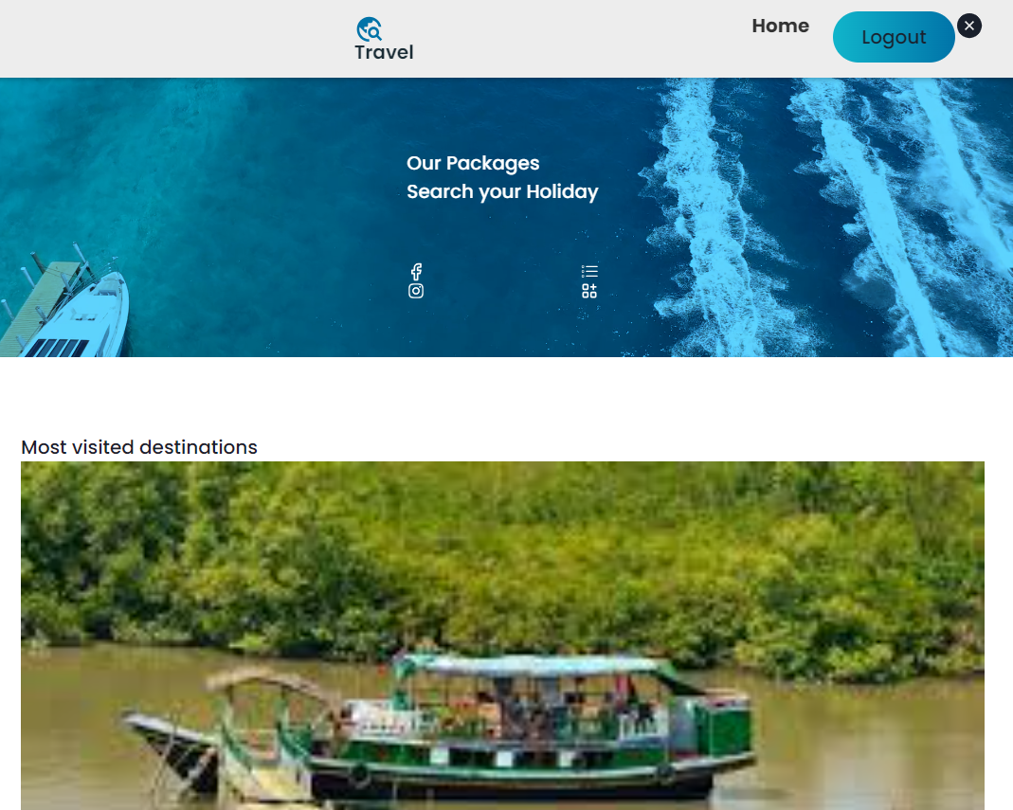

**Purpose:**

The purpose of the Home Page in a reservation system is to serve as the main gateway for users, providing a welcoming and informative entry point that facilitates easy navigation and access to key features.

**Key Features:**

1. **Header with Navigation Menu:**

* Include a clear and organized navigation menu to direct users to different sections of the reservation system.

1. **Search Bar:**

* Feature a prominent search bar to allow users to quickly find specific tours, hotels, or services.

1. 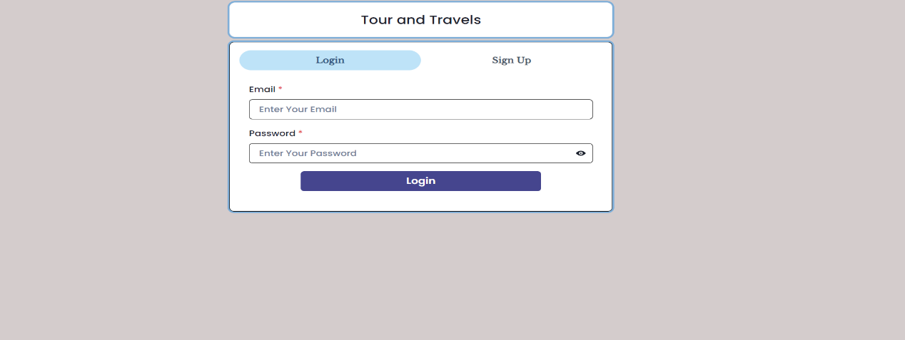**Login Page:**

**Purpose:** The login page serves as the initial point of entry for registered users, allowing them to access personalized features and account information.

**Key Features:**

1. **Username and Password Fields:**

• Users enter their registered username and password for authentication.

• Passwords are encrypted to ensure secure transmission and storage.

1. **Forgot Password:**

• Link or option to reset a forgotten password via email verification.

1. **Registration Page:**

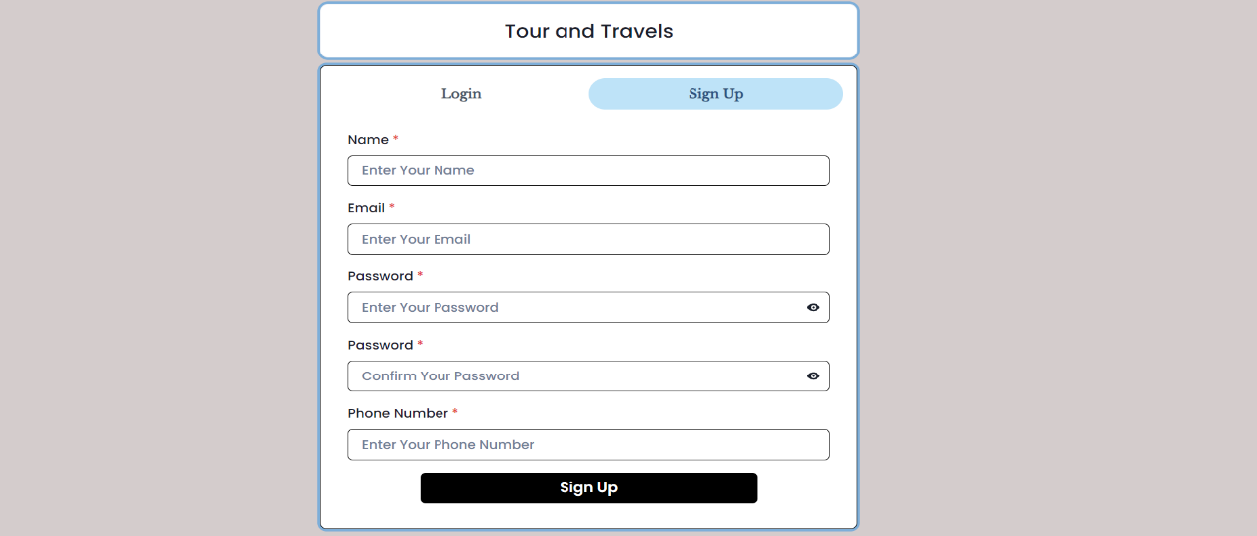

**Purpose:** The registration page allows new users to create an account, providing them access to personalized services and features.

**Key Features:**

1. **User Information Fields:**

• Collects essential information such as name, email address, and contact details.

1. **Username and Password Creation:**

• Users choose a unique username and set a secure password.

1. **Tour List Page:**

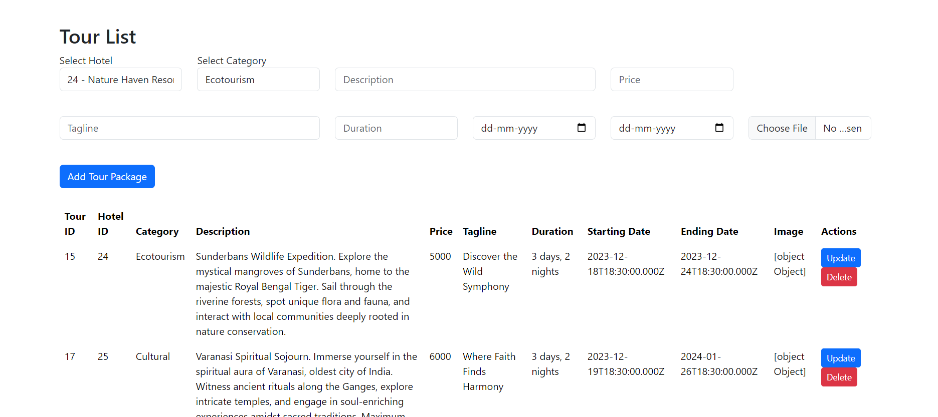

**Purpose:** The Tour List in a Tour and Travel System serves as a comprehensive catalogue of available tours, providing users with detailed information about various travel packages and destinations.

**Key Features:**

1. **Tour Details:**

* Description: A brief overview of the tour, including highlights, activities, and key attractions.
* Duration: The length of the tour, specifying the number of days and nights included.

1. **Destination Information:**

* Location: Clearly specifying the destination(s) covered by the tour.
* Points of Interest: Highlighting key attractions and landmarks included in the tour.

1. **Pricing and Inclusions:**

* Tour Cost: Clearly stating the price of the tour, including any additional fees or optional add-ons.
* Inclusions: Providing a list of services or amenities covered in the tour cost, such as accommodations, meals, transportation, and guided tours.

1. **Tour Package Details Page:**

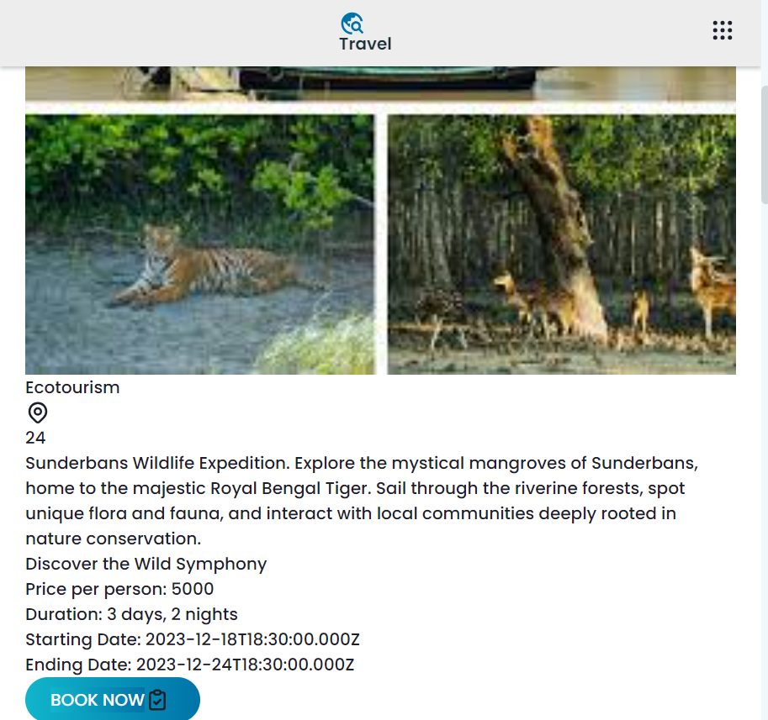

**Purpose:**

The purpose of the Tour Package Details page in a reservation system is to provide users with comprehensive and detailed information about a specific tour package.

**Key Features:**

1. **Tour Description:**

* Provide a detailed and engaging description of the tour package, highlighting its unique aspects and selling points.

1. **Duration and Dates:**

* Clearly state the duration of the tour and the available dates for booking.

1. **Pricing Information:**

* Display the cost of the tour, including any additional fees, taxes, or discounts.

1. 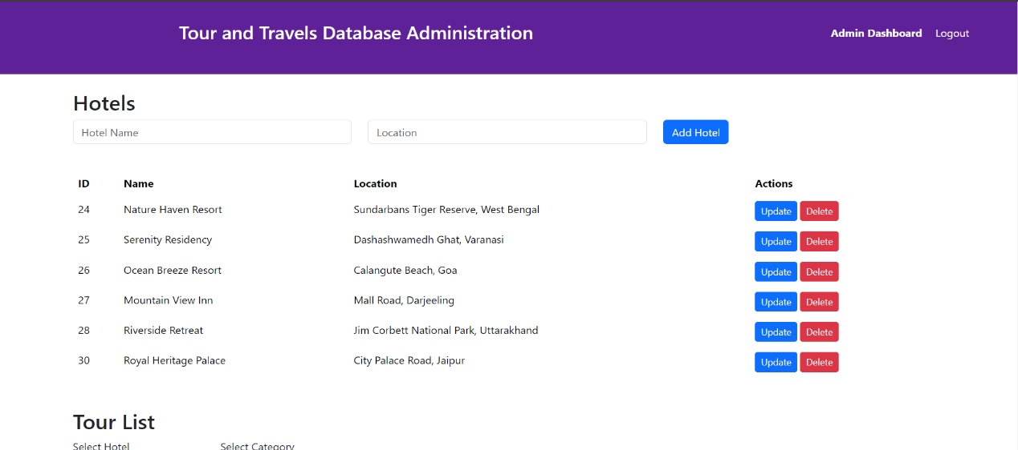**Hotel List Page:**

**Purpose:** The Hotel List in a Hotel Reservation System serves as a centralized repository of available accommodations, providing users with essential information to make informed decisions when booking hotel stays.

**Key Features:**

1. **Hotel Details:**

* Name and Location: Clearly displaying the hotel's name and exact location.
* Description: Offering a concise overview of the hotel, including its facilities, services, and unique features.

1. **User Booking Details Page:**

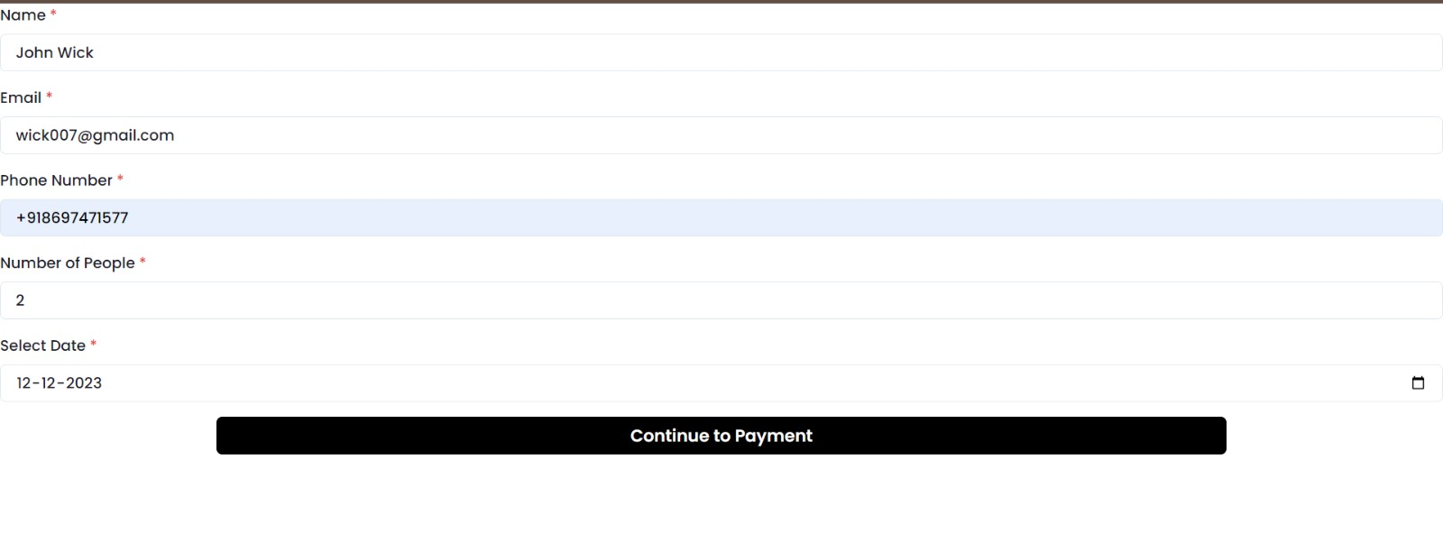

**Purpose:** The User Booking Details section is a crucial component of a reservation system, providing users with a comprehensive overview of their booking information before finalizing the reservation.

**Key Features:**

1. **Booking Information:**

* Service Type: Clearly indicating whether it's a hotel reservation, tour booking, or other services.
* Booking Reference/ID: Providing a unique identifier for the booking for future reference.

1. **Date**:

* Booking Dates: Displaying the start and end dates of the reservation.

1. **Payment Option Page:**

**Purpose:** The Payment Options Page in a reservation system is the interface where users can securely and conveniently select their preferred method of payment to complete the booking process.

**Key Features:**

1. **Payment Methods:**

* Credit/Debit Cards: Providing fields for users to enter their card details, including card number, expiration date, and CVV.
* Digital Wallets: Offering options for popular digital wallets such as PayPal, Apple Pay, Google Pay, etc.

1. **Payment via Debit Card Page:**

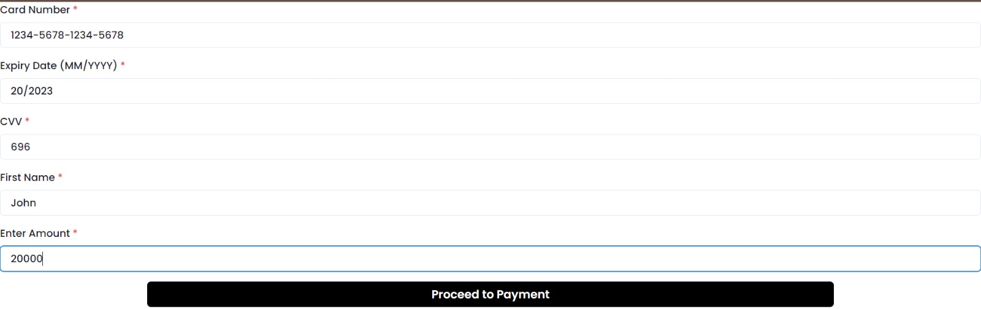

**Purpose:** The purpose of the Payment via Debit Card Page in a reservation system is to facilitate a secure and convenient transaction method for users who prefer to use their debit cards for making payments.

**Key Features:**

1. **Debit Card Information:**

* Card Number, Expiry Date, and CVV: Clearly labelled fields for users to enter their debit card details.
* Card Type Recognition: Automatically detecting the card type based on the entered card number for user convenience.

1. 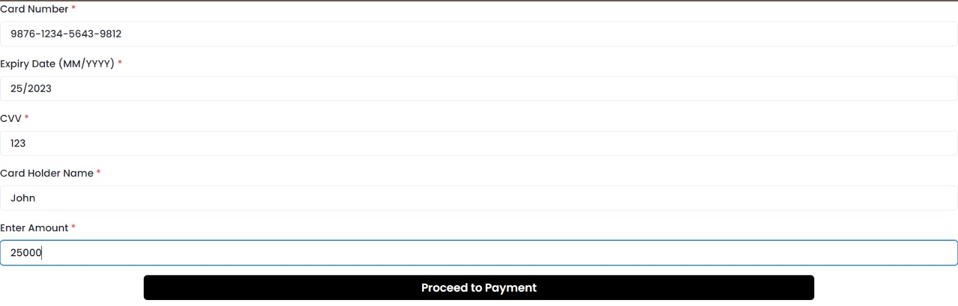**Payment via Credit Card Page:**

**Purpose:** The purpose of the Payment via Credit Card Page in a reservation system is to provide users with a secure and convenient platform to complete transactions using their credit cards.

**Key Features:**

1. **Credit Card Information:**

* Card Number, Expiry Date, and CVV: Clearly labelled fields for users to enter their debit card details.
* Card Type Recognition: Automatically detecting the card type based on the entered card number for user convenience.

1. **Payment via UPI Page:**

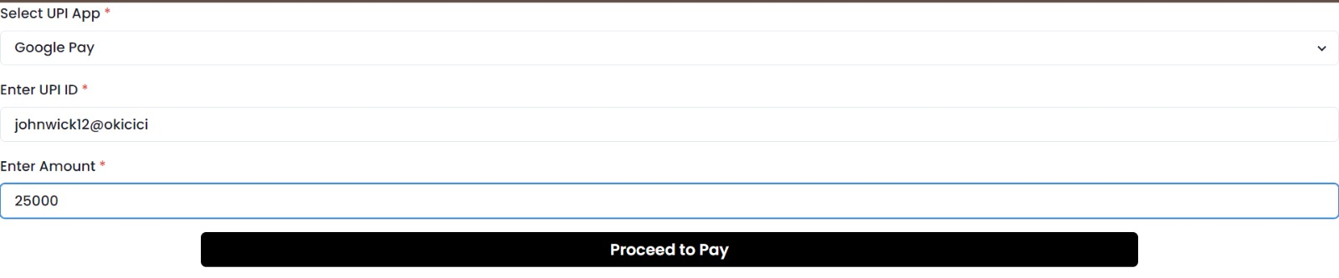

Purpose: The purpose of the Payment via UPI (Unified Payments Interface) Page in a reservation system is to offer users a streamlined and secure platform to make transactions using the UPI payment method.

**Key Features:**

1. **UPI Credential Entry:**

* Provide a secure space for users to enter their UPI credentials, including their UPI ID or linked mobile number.